**Exercise 1: Print First 10 natural numbers using while loop**

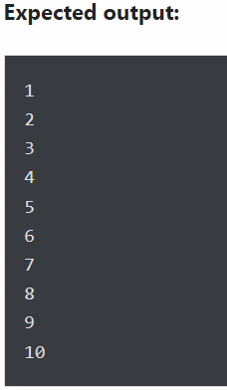

count=1

while count<11:

print(count)

count+=1

1

2

3

4

5

6

7

8

9

10

### Exercise 2: Write a program to print multiplication table of a given number

### list=[1,2,3,4,5,6,7,8,9,10]

### n=4

### for i in list:

### c=n*i

### print(c)

4

8

12

16

20

24

28

32

36

40

### Exercise 3: Display numbers from a list using loop

Write a program to display only those numbers from a [list](https://pynative.com/python-lists/) that satisfy the following conditions

* The number must be divisible by five
* If the number is greater than 150, then skip it and move to the next number
* If the number is greater than 500, then stop the loop

numbers = [12, 75, 150, 180, 145, 525, 50]

for item in numbers:

if item > 500:

break

elif item > 150:

continue

elif item % 5 == 0:

print(item)

75

150

145

### 

### Exercise 4: Count the total number of digits in a number

Write a program to count the total number of digits in a number using a [while loop](https://pynative.com/python-while-loop/).

For example, the number is **75869**, so the output should be **5**.

num = 75869

count = 0

while num != 0:

num = num // 10

count = count + 1

print("Total digits are:", count)

Total digits are: 5

### 

### Exercise 5: Print the following pattern

### Write a program to use for loop to print the following reverse number pattern

### 

### n = 5

### k = 5

### for i in range(0,6):

### for j in range(5-i,0,-1):

### print(j,end=' ')

### print()

5 4 3 2 1

4 3 2 1

3 2 1

2 1

1

### 

### Exercise 6: Print list in reverse order using a loop

### 

### list1 = [10, 20, 30, 40, 50]

### new_list = reversed(list1)

### for item in new_list:

### print(item)

50

40

30

20

10

### 

### Exercise 7: Use else block to display a message “one” after successful execution of for loop

### 

### for i in range(5):

### print(i)

### else:

### print("Done!")

0

1

2

3

4

Done!

### Exercise 8: Use a loop to display elements from a given list present at odd index positions

### 

### for i in my_list[1::2]:

### print(i, end=" ")

20 40 60 80 100

### 

### Exercise 9: Calculate the cube of all numbers from 1 to a given number

### Write a program to rint the cube of all numbers from 1 to a given number

### 

### input_number = 6

### for i in range(1, input_number + 1):

### print("Current Number is :", i, " and the cube is", (i * i * i))

Current Number is : 1 and the cube is 1

Current Number is : 2 and the cube is 8

Current Number is : 3 and the cube is 27

Current Number is : 4 and the cube is 64

Current Number is : 5 and the cube is 125

Current Number is : 6 and the cube is 216

### 